Amp Documentation

The Amplifier project contains 5 modular parts.

* 15volt 7+amp power supply
* 5volt 1amp power supply
* Audio amplifier with 2 channels, 35watt per channel.
* Stereo Audio integrator (to smooth out dot-bar display)
* 2x dot bar display (one for each channel)

In this project an audio signal from an ipod or other low-voltage audio device, is measured by a volume meter and amplified by a TDA7375V.

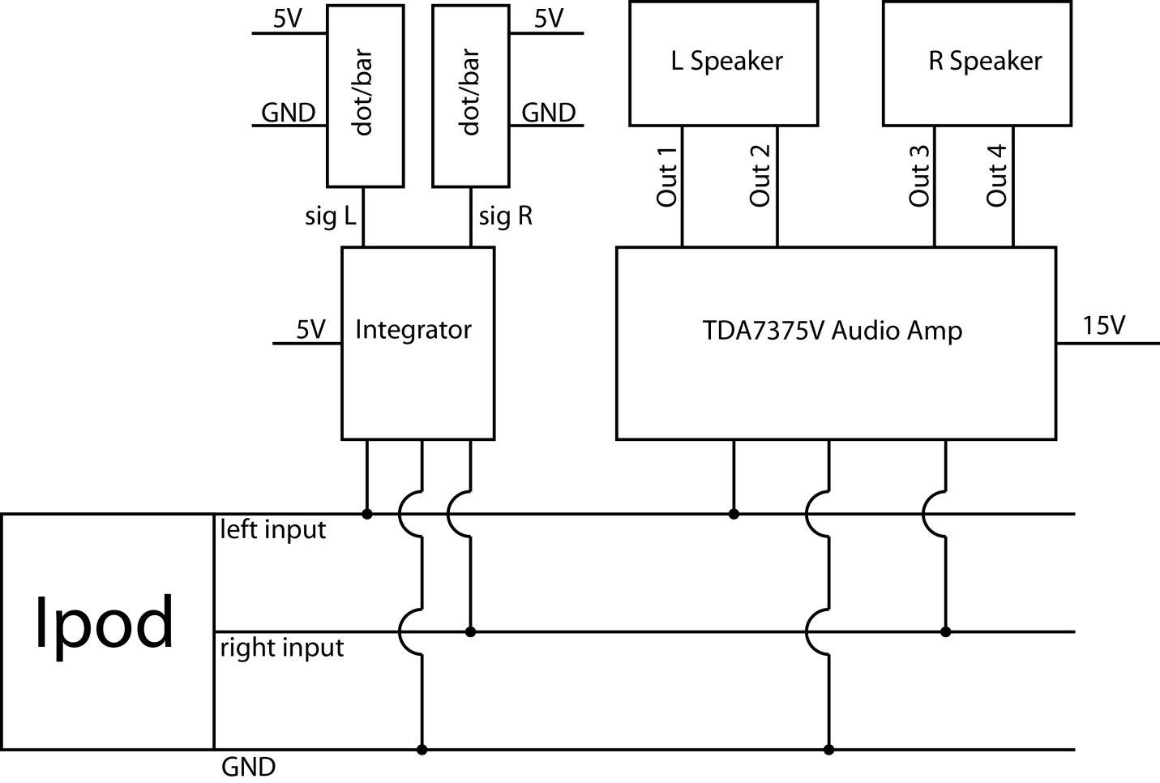

Electrical Characteristics and Parameters

* Ipod
  + Voltages of up to ±1.5 volts relative to GND
* Audio Amp
  + Voltage range 8V to 18V
  + Max output power: 35 watts per channel
  + Voltage gain 26 db ≈ 19.95
* Integrator
  + Max supply and input voltages of 5V
* Dot-Bar display
  + Able to map from 0V to (Supply Voltage -1.5V)
  + R1 (initially set to 3.3k) changes mapping range
  + Check the range by measuring voltage on pin 6
  + When R1 = 220Ω; Refhigh ≈ 1.5volts
  + Pushbutton
    - down = bar mode
    - up = dot mode
    - a wire can be used instead of a button for always bar mode
  + Clip plus and Clip minus can be connected to the audio amp

Notes:

GND means Ground and each ground for every circuit should be connected together

* Ipod
  + Voltages can be measured using the oscilloscope. This is good for eyeballing the voltage it produces when at certain volume levels
* Audio Amp
  + C = clip+
  + + = +15V
  + S = GND
  + G = GND
  + 1/3 means audio input left/right or channel1/channel2
  + Output 1 & 2 are connected to input 1
  + Output 3 & 4 are connected to input 3
  + The device will be in stand-by (not playing music) when the voltage on the stand-by pin is less than 5V
  + The ST-BY pin can withstand 15V given a strong resistor 10k+
* Integrator
  + Is two channel (it can run two dot bar displays)
  + Potentiometers can be replaced with wire because they only divide the voltage from the ipod
  + The integrator acts as a 0 voltage drop diode, therefor, polarized caps can be kept from reverse polarization
  + Both [GND and 5V] terminals are in parallel for convenience